

**A Short Report on**

**Filter Specifications and Design of Digital Filter Based on given specifications**

**[ 4. Talk about filter specifications and how to design a digital filter based on the given specifications.]**

**Student ID: 201324060127**

**Name: Abhishek Pratap Sah**

**School: School of Communication and Information Engineering**

**Submitted To:**

**Prof. Jing-Ran Lin**

**(qpeng@uestc.edu.cn, jingranlin@uestc.edu.cn)**

**Table of Contents**

Introduction 3

Digital Versus Aanalog Filtering 4

Digital Filter 4

Specifications for Digital Filter Design 5

Design Approach Using 9

Finite Impulse Response (FIR) 9

Characteristics of FIR filters 9

FIR Filter Design Approach 10

Design of FIR Filters by Window’s 10

Design of FIR Filters by Frequency Sampling 13

Infinite Impulse Response (IIR) 14

IIR Characteristics 14

IIR Filter Design Steps 14

Analog Filter Techniques 15

Butterworth Filter 15

Chebyshev Analog Filter 17

Analog to Digital Transformation Using Bilinear Transformation 19

References 22

**INTRODUCTION**

Digital filtering is one of the most powerful tools of DSP. Apart from the obvious advantages of virtually eliminating errors in the filter associated with passive component fluctuations over time and temperature, op amp drift (active filters), etc., digital filters are capable of performance specifications that would, at best, be extremely difficult, if not impossible, to achieve with an analog implementation. In addition, the characteristics of a digital filter can be easily changed under software control. Therefore, they are widely used in adaptive filtering applications in communications such as echo cancellation in modems, noise cancellation, and speech recognition.

The rise of digital filtering has come about as a result of two factors which are not totally independent. The first is traceable to the fact that more process control and signal processing operations are now being executed digitally which were previously accomplished in the analog domain. Once signals are in a digital format, it is obviously more efficient to complete all necessary operations digitally. The second factor bringing about a more widespread application of digital filters is the continuing decrease in cost per digital hardware function. This is due to advances in the state-of-the-art and economic factors of high volume production. Digital filters, therefore, may be realized with either software as a part of a larger executive program, or in a hardwired hardware form, with perhaps A/D and D/A input and output converters, to accomplish a specific filtering task.

The decision of when to use digital filters instead of, for example, active type analog filters is not dictated by hard-and-fast guidelines. This decision is strictly dependent upon the application at hand. The principal features of digital filters are high stability and the ease with which filter parameters can be changed. The former is useful for separating signals very close in frequency and where the filter must be located in other than ideal environments. The latter feature is essential for adaptive filtering where a filter must change its characteristics in real-time to a changing input signal.

The actual procedure for designing digital filters has the same fundamental elements as that for analog filters. First, the desired filter responses are characterized, and the filter parameters are then calculated. Characteristics such as amplitude and phase response are derived in the same way. The key difference between analog and digital filters is that instead of calculating resistor, capacitor, and inductor values for an analog filter, coefficient values are calculated for a digital filter. So for the digital filter, numbers replace the physical resistor and capacitor components of the analog filter. These numbers reside in a memory as filter coefficients and are used with the sampled data values from the ADC to perform the filter calculations.

**Digital Versus Aanalog Filtering**

|  |  |
| --- | --- |
| Digital Filters | Analog Filters |
| High Accuracy  Linear Phase (FIR Filters)  No Drift Due to Component  Variations  Flexible, Adaptive Filtering Possible  Easy to Simulate and Design  Computation Must be Completed in  Sampling Period - Limits Real Time  Operation  Requires High Performance ADC,  DAC & DSP | Less Accuracy - Component  Tolerances  Non-Linear Phase  Drift Due to Component  Variations  Adaptive Filters Difficult  Difficult to Simulate and Design  Analog Filters Required at  High Frequencies and for  Anti-Aliasing Filters  No ADC, DAC, or DSP Required |

**Digital Filter**

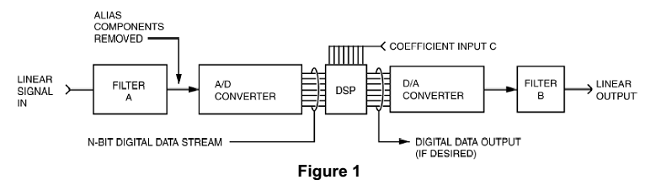

Digital filters process digitized or sampled signals. A digital filter computes a quantized time-domain representation of the convolution of the sampled input time function and a representation of the weighting function of the filter. They are realized by an extended sequence of multiplications and additions carried out at a uniformly spaced sample interval. Simply said, the digitized input signal is mathematically influenced by the DSP program. These signals are passed through structures that shift the clocked data into summers (adders), delay blocks and multipliers. These structures change the mathematical values in a predetermined way; the resulting data represents the filtered or transformed signal.

It is important to note that distortion and noise can be introduced into digital filters simply by the conversion of analog signals into digital data, also by the digital filtering process itself and lastly by conversion of processed data back into analog. When fixed-point processing is used, additional noise and distortion may be added during the filtering process because the filter consists of large numbers of multiplications and additions, which produce errors, creating truncation noise. For most applications, as long as the A/D and D/A converters have high enough bit resolution, distortions introduced by the conversions are less of a problem.

**Specifications for Digital Filter Design**

Determination of a realizable transfer function G(z) approximating a given frequency response specification is an important step in the development of a digital filter. Usually, either the magnitude and/or the phase (delay) response is specified for the design of digital filter for most applications and in some situations, the unit sample response or the step response may be specified. Whereas, in most practical applications, the problem of interest is the development of a realizable approximation to a given magnitude response specification.

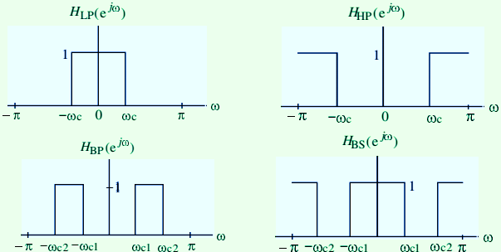There are four basic types of ideal filters with magnitude responses as shown below:

**Figure 2: Different kinds of Filters**

As the impulse response corresponding to each of these ideal filters is non-causal and of infinite length, these filters are not realizable, in practice, the magnitude response specifications of a digital filter in the passband and in the stopband are given with some acceptable tolerances. In addition, a transition band is specified between the passband and stopband.

For example, the magnitude response of a digital lowpass filter may be given as indicated below:

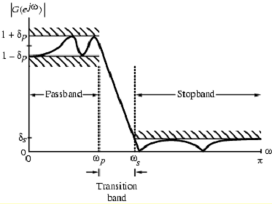

**Figure 3: Low Pass Filter**

As indicated in the figure, in the passband, defined by , we require that

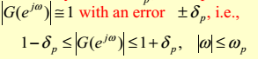

In the stopband, defined by , we require that with an error , i.e.,



ωp - passband edge frequency

ωS - stopband edge frequency

δs- peak ripple value in the passband

δs - peak ripple value in the stopband



Since *G(ej*ω*)* is a periodic function of ω, and of a real-coefficient digital filter is an even function of ω as a result, filter specifications are given only for the frequency range

.

Specifications are often given in terms of loss function, in dB.

Peak passband ripple is

Minimum stopband attenuation is

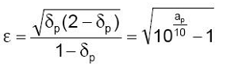

Magnitude specifications may alternately be given in a normalized form as indicated below:

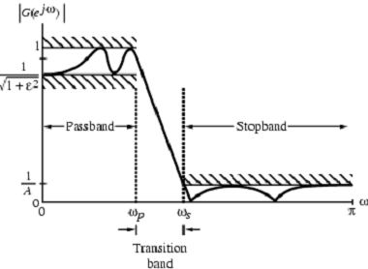

**Figure 4: Low Pass Filter**

Here, the maximum value of the magnitude in the passband is assumed to be unity and maximum passband deviation, given by the minimum value of the magnitude in the passband and is maximum stopband magnitude.

For the normalized specification, maximum value of the gain function or the minimum value of the loss function is 0 dB.

Maximum passband attenuation is

For δp <<1, it can be shown that

In practice, passband edge frequency *Fp*  and stopband edge frequency *Fs* are specified in Hz.

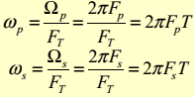For digital filter design, normalized bandedge frequencies need to be computed from specifications in Hz using

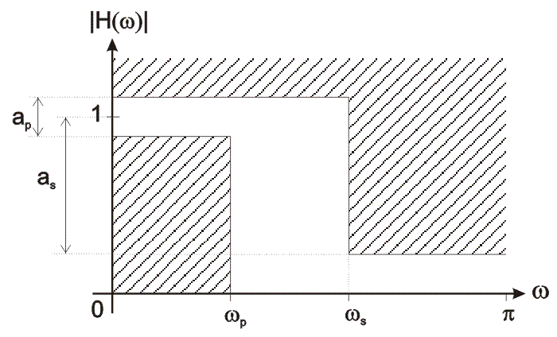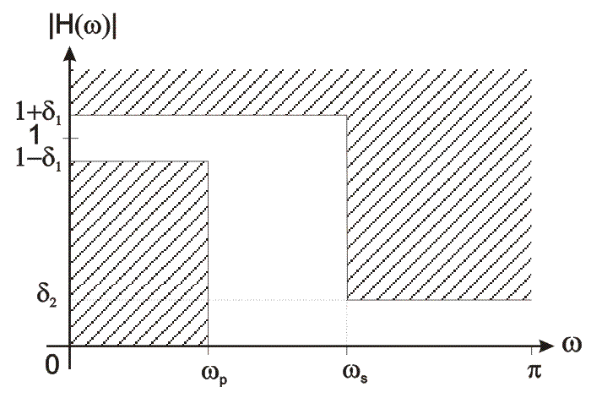

**Figure 5: Low-pass digital filter specification**

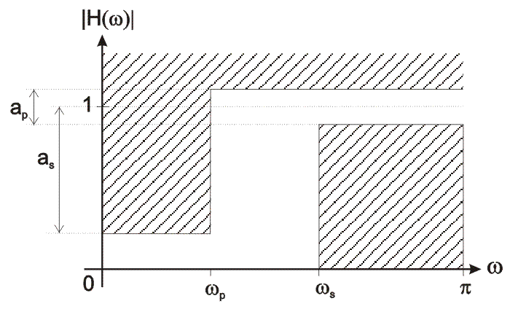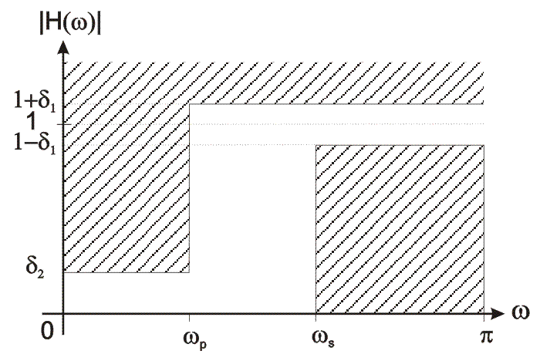

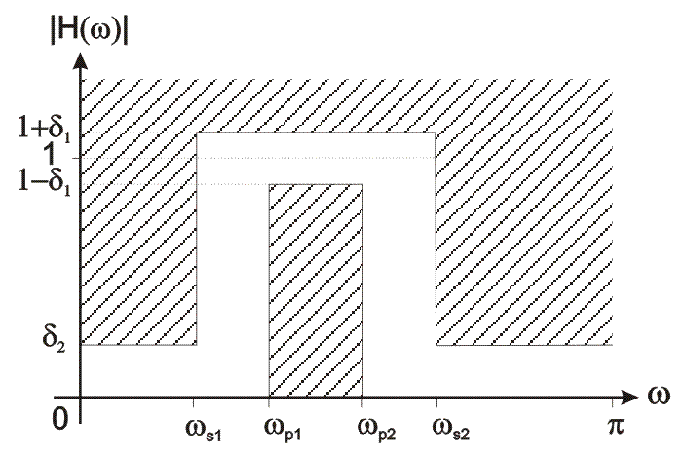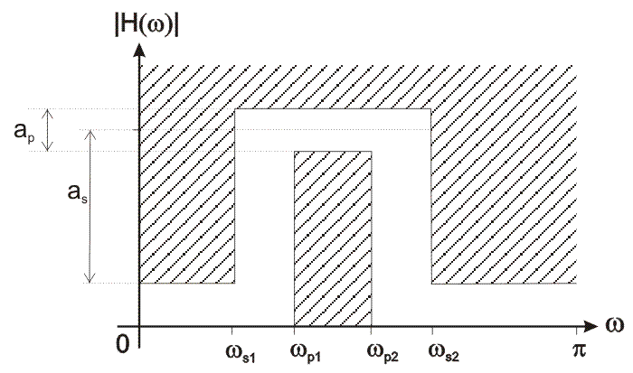**Figure 6: High-pass digital filter specification**

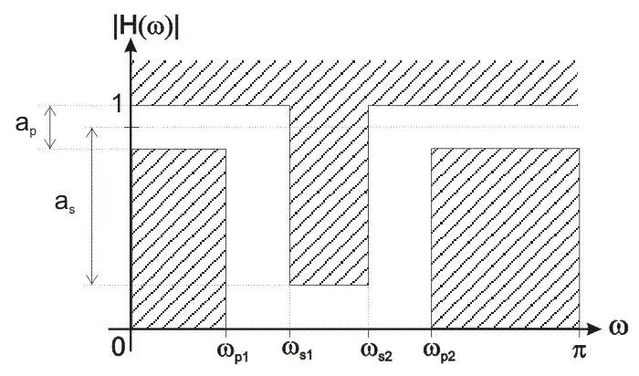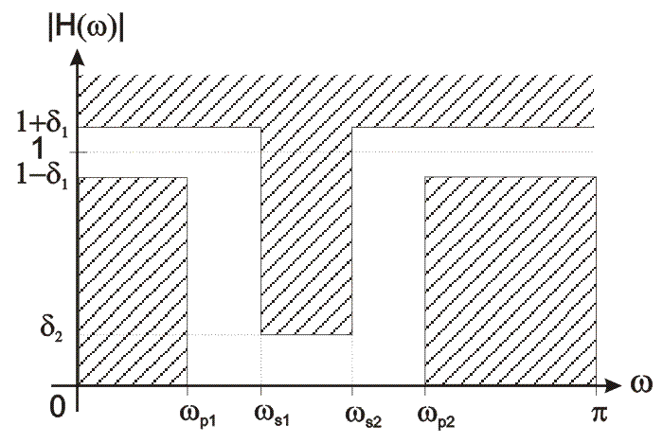**Figure 7: Band-pass digital filter specification**

**Figure 8: Band-stop digital filter specification**

**Design Approach Using:**

* **Finite Impulse Response (FIR) and**
* **Infinite Impulse Response (IIR)**

**Finite Impulse Response (FIR)**

As the terminology suggests, these classifications refer to the filter’s impulse response. By varying the weight of the coefficients and the number of filter taps, virtually any frequency response characteristic can be realized with an FIR filter. As has been shown, FIR filters can achieve performance levels which are not possible with analog filter techniques (such as perfect linear phase response). However, high performance FIR filters generally require a large number of multiply-accumulates and therefore require fast and efficient DSPs.

**Characteristics of FIR filters**

* **Impulse Response has a Finite Duration (N Cycles)**
* **Linear Phase, Constant Group Delay (N Must be Odd)**
* **No Analog Equivalent**
* **Unconditionally Stable**
* **Can be Adaptive**
* **Computational Advantages when Decimating Output**
* **Easy to Understand and Design**
  + **Windowed-Sinc Method**
  + **Fourier Series Expansion with Windowing**
  + **Frequency Sampling Using Inverse FFT - Arbitrary Frequency Response**

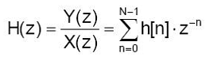

FIR filter transfer function can be expressed as:

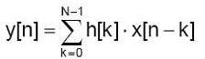The frequency response realized in the time domain is of more interest for FIR filter realization (both hardware and software). The transfer function can be found via the z-transform of a FIR filter frequency response. FIR filter output samples can be computed using the following expression:

where:

x[k] are FIR filter input samples;

h[k] are the coefficients of FIR filter frequency response; and

y[n] are FIR filter output samples.

**FIR Filter Design Approach**

* FIR filter design is based on a direct approximation of the specified magnitude response, with the often added requirement that the phase be linear.
* The design of an FIR filter of order N may be accomplished by finding either the length-(N+1) impulse response samples {h[n]} or the (N+1) samples of its frequency response H(ejw)
* Three commonly used approaches to FIR filter design -

(1) Windowed Fourier series approach

(2) Frequency sampling approach

(3) Computer-based optimization methods

**Design of FIR Filters by Window’s** : The simplest technique is known as “Windowed” filters. This technique is based on designing a filter using well-known frequency domain transition functions called “windows”. The use of windows often involves a choice of the lesser of two evils. Some windows, such as the Rectangular, yield fast roll-off in the frequency domain, but have limited attenuation in the stop-band along with poor group delay characteristics. Other windows like the Blackman, have better stop-band attenuation and group delay, but have a wide transition-band (the band-width between the corner frequency and the frequency attenuation floor). Windowed filters are easy to use, are scalable (give the same results no matter what the corner frequency is) and can be computed on-the-fly by the DSP. This latter point means that a tunable filter can be designed with the only limitation on corner frequency resolution being the number of bits in the tuning word.

The FIR filter design process via window functions can be split into several steps:

1. Defining filter specifications;
2. Specifying a window function according to the filter specifications;
3. Computing the filter order required for a given set of specifications;
4. Computing the window function coefficients;
5. Computing the ideal filter coefficients according to the filter order;
6. Computing FIR filter coefficients according to the obtained window function and ideal filter coefficients;
7. If the resulting filter has too wide or too narrow transition region, it is necessary to change the filter order by increasing or decreasing it according to needs, and after that steps 4, 5 and 6 are iterated as many times as needed.

**Example 1**

**Step 1:**

Type of filter – low-pass filter

Filter specifications:

* Filter order – N=10
* Sampling frequency – fs=20KHz
* Passband cut-off frequency – fc=2.5KHz

**Step 2:**

Method – filter design using rectangular window

**Step 3:**

Filter order is predetermined, N=10;

A total number of filter coefficients is larger by one, i.e. N+1=11; and

Coefficients have indices between 0 and 10.

**Step 4:**

All coefficients of the rectangular window have the same value equal to 1.

w[n] = 1 ; 0 ≤ n ≤10

**Step 5:**

The ideal low-pass filter coefficients (ideal filter impulse response) are expressed as:

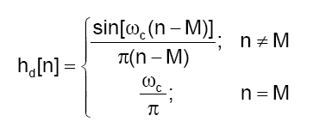

where M is the index of middle coefficient.

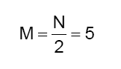

Normalized cut-off frequency ωc can be calculated using the following expression:

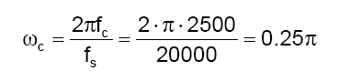

The values of coefficients (rounded to six digits) are obtained by combining the values of M and ωc with expression for the impulse response coefficients of the ideal low-pass filter:

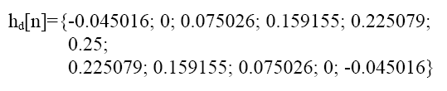

The middle element is found via the following expression

Formula 2-4-1-5

**Step 6:**

The designed FIR filter coefficients are obtained via the following expression:

Formula 2-4-1-6

The FIR filter coefficients h[n] rounded to 6 digits are:

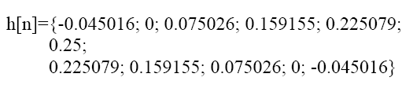

**Step 7:**

The filter order is predetermined.

There is no need to additionally change it.

**Filter realization:**

Figure 2-4-1 illustrates the direct realization of designed FIR filter, whereas Figure 2-4-2 illustrates the optimized realization of designed FIR filter, which is based on the fact that all FIR filter coefficients are, for the sake of linear phase characteristic, symmetric about their middle element.

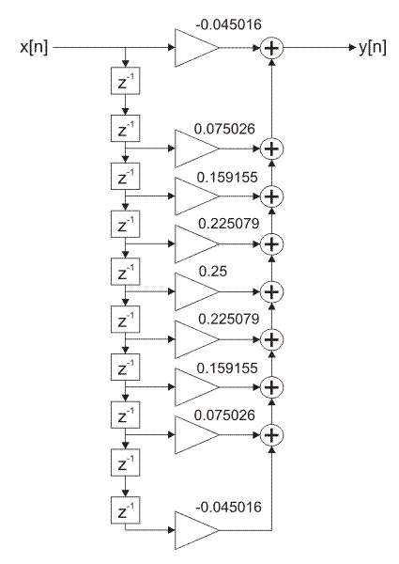

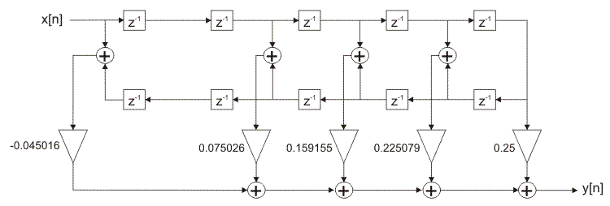

**Figure 9: FIR filter direct realization Figure 10: Optimized realization structure of FIR filter**

**Design of FIR Filters by Frequency Sampling**

For the frequency sampling method of FIR filter design, to design a M -point FIR filter we specify the desired frequency response at a set of equally-spaced frequency locations:



In other words, we provide equally spaced samples over [0; 2π).

if hd[n] is nonzero only for n = 0,…… M-1, then

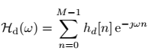

Thus, at the given frequency locations, we have



This is the formula for the M -point DFT.

So we can determine hd[n] from  by using the inverse DFT formula



This will be the impulse response of the FIR filter as designed by the frequency sampling method.

**Infinite Impulse Response (IIR)**

IIR filters are digital filters with infinite impulse response. Unlike FIR filters, they have the feedback (a recursive part of a filter) and are known as recursive digital filters therefore. For this reason IIR filters have much better frequency response than FIR filters of the same order. Unlike FIR filters, their phase characteristic is not linear which can cause a problem to the systems which need phase linearity. For this reason, it is not preferable to use IIR filters in digital signal processing when the phase is of the essence. Otherwise, when the linear phase characteristic is not important, the use of IIR filters is an excellent solution.

The most commonly used IIR filter design method uses reference analog prototype filter. It is the best method to use when designing standard filters such as low-pass, high-pass, bandpass and band-stop filters. The filter design process starts with specifications and requirements of the desirable IIR filter. A type of reference analog prototype filter to be used is specified according to the specifications and after that everything is ready for analog prototype filter design. The next step in the design process is scaling of the frequency range of analog prototype filter into desirable frequency range. This is how an analog prototype filter is converted into an analog filter. After the analog filter is designed, it is time to go through the last step in the digital IIR filter design process. It is conversion from analog to digital filter. The most popular and most commonly used converting method is bilinear transformation method. The resulting filter, obtained in this way, is always stable. However, instability of the resulting filter, when bilinear transformation is used, may be caused only by the finite word-length side-effect.

**IIR Characteristics:**

* Uses Feedback (Recursion)
* Impulse Response has an Infinite Duration
* Potentially Unstable
* Non-Linear Phase
* More Efficient than FIR Filters
* No Computational Advantage when DecimatingOutput
* Usually Designed to Duplicate Analog Filter Response
* Usually Implemented as Cascaded Second-Order Sections (Biquads)

**IIR Filter Design Steps**

* Choose prototype analog filter family
  + Butterworth
  + Chebyshev Type I or II
  + Elliptic
* Choose analog-digital transformation method
  + Impulse Invariance
  + Bilinear Transformation
* Transform digital filter specifications to equivalent analog filter specifications
* Design analog filter
* Transform analog filter to digital filter
* Perform frequency transformation to achieve highpass or bandpass filter, if desired.

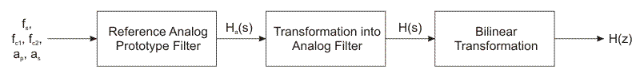

**Figure: Block diagram for IIR Filter Design Steps**

The traditional approach to the design of IIR digital filters involves the transformation of an analog filter in to a digital filter meeting prescribed specifications. This is a reasonable approach because:

* The art of analog filter design is highly advanced and since useful results can be achieved, it is advantageous to utilize the design procedures already developed for analog filters.
* Many useful analog design methods have relatively simple closed-form design formulas. Therefore, digital filter design methods based on analog design formulas are rather simple to implement.

An analog system can be described by the differential equation:

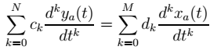

And the corresponding rational function is:



The corresponding description for digital filters has the form:



and the rational function:



In transforming an analog filter to a digital filter we must therefore obtain either H(z) or h(n) (inverse z-transform of H(z) i.e., impulse response) from the analog filter design.

**Analog Filter Techniques**

**Butterworth Analog Filter**

Low-pass Butterworth analog filters are filters whose frequency response is a monotonious descending function. They are also known as „maximally flat magnitude“ filters at the frequency of Ω = 0, as the first 2N - 1 derivatives of the transfer function when Ω = 0 are equal to zero.

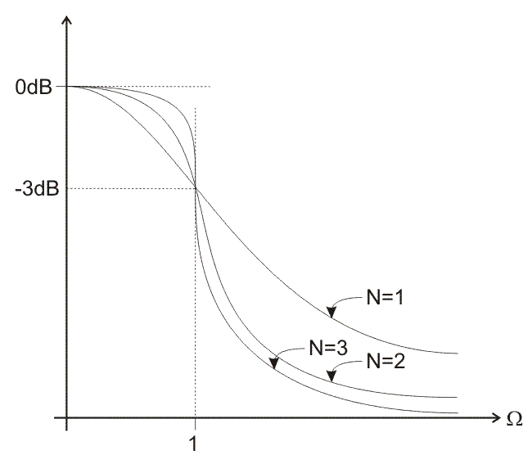Butterworth filter is characterized by 3dB attenuation at the frequency of Ω=1, no matter the filter order is. The Figure: 11 below illustrates frequency responses for a few various parameters N (filter order).

**Figure: 11**

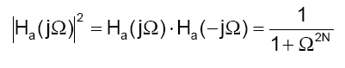Butterworth filter is defined via expression:

where: Ω is the frequency; and N is the filter order.

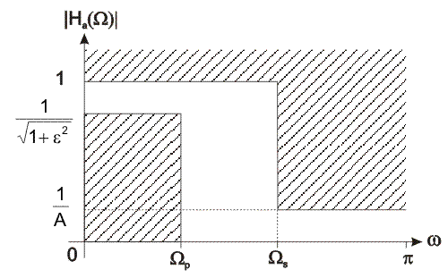

**Figure 12: IIR filter specification**

Above figure illustrates IIR filter specification with parameters of most interest for Butterworth filter.

To design Butterworth reference analog prototype filter, it is necessary to know the filter order. All poles of the resulting filter must be located in the left half of the S plane, i.e. to the left of the imaginary axis.

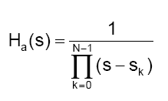The transfer function of the Butterworth reference analog prototype filter is expressed as follows:

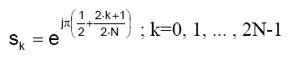where: Sk is the k-th pole of the Butterworth filter transfer function given by:

**Chebyshev Analog Filter**

Chebyshev analog low-pass filter of the first kind is a type of analog filter that has the least oscillation in frequency response in the entire passband. Therefore it is characterized by equal ripple in the passband and the stopband frequency response is monotonously descending function.

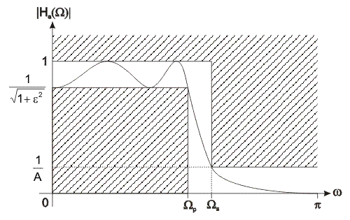The Figure: 13 below illustrates frequency response for a 4th order band-stop Chebyshev reference analog filter.

**Figure: 13**

To design Chebyshev reference analog prototype filter, it is necessary to know the filter order. Chebyshev analog filter is defined via expression:

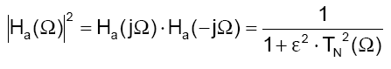

where:  
Ω is the frequency;  
N is the filter order;  
ε is a parameter used to define maximum oscillations in the passband frequency response; and  
TN is the Chebyshev polynomial.

The Chebyshev polynomial TN(Ω) can be obtained via recursive relations:

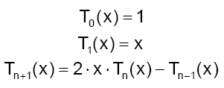

If the filter order is known in advance, neither recursive relations nor expression for the square of frequency response are necessary. The design process starts from the values of poles of a 1st order Chebyshev reference analog filter.

The values of poles are expressed as:

C:\Users\dragonking\Desktop\for3-3-8.gifwhere:  
si is the i-th transfer function pole of analog prototype filter (complex value);

σi is the pole; and Ωi is the imaginary pole.

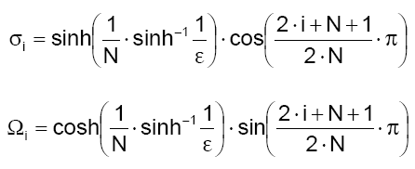

where:  
N is the filter order; and  
i=1, 2, ..., N.

The value of parameter ε is obtained via expression:

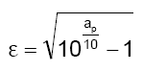

Transfer function is expressed as:

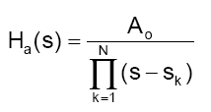

The value of A0 is found via expression:

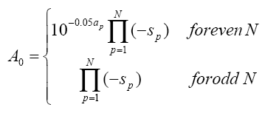

For example For N=5, the transfer function is:

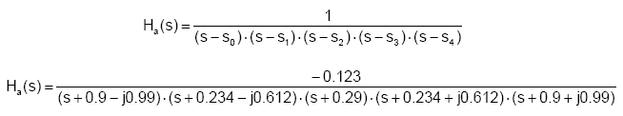

**Analog to Digital Transformation Using Bilinear Transformation**

Digital IIR filters are designed using analog filters. After the frequency scaling and transformation into a desirable type of filter have been performed, it is necessary to transform the resulting analog filter into a digital one. It is done by transforming the analog filter transfer function into a digital one.

The transformation is supposed to:

1. faithfully approximate the frequency response of analog filter; and
2. provide that the resulting digital filter is guaranteed to be stable.

This transformation also transforms s plane into z plane.

Analog filter is stable if the poles of the transfer function are located in the left half of s plane, whereas digital filter is stable if the poles are located within the unit circle. For this reason, the transformation must provide that the left half of s plane coincides with the area within the unit circle of z plane, as shown in Figure below:

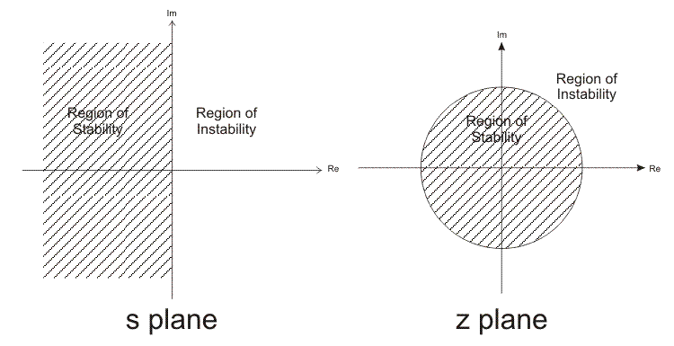

**Figure: 14**

One of most commonly used method of transforming analog filters into appropriate IIR filters is known as bilinear transformation. It is defined via expression:

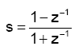

Using the previous expression, the transformation of the analog filter transform function into a digital one can be expressed as:

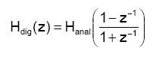

As seen, the transformation is performed by a simple change of variable s in the expression for the transfer function of the resulting analog filter.

The analog filter transfer function can be expressed as:

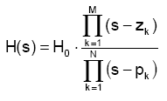

where:  
H0 is a constant. If s=0 then H(s)=H0 ;  
zk is the zero of the analog filter transfer function; and  
pk is the pole of the analog filter transfer function.

After transformation, the analog filter transfer function is further transformed into:

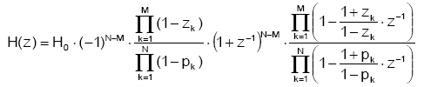

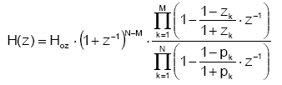

where:  
Hoz is a constant of the digital IIR filter transfer function given by:

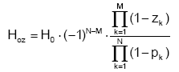

**For Example:** The transfer function of a second-order high-pass analog filter (inverse Chebyshev, fc=2KHz, fs=44100Hz, 60dB) is expressed as:

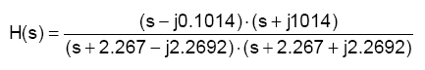

It is necessary to transform the given analog filter into the appropriate digital filter by bilinear transformation. Using expression for linear transformation:

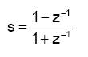

we obtain:

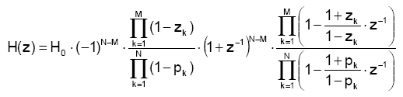

where:  
N=2  
M=2  
z1=j0.1014  
z2=-j0.1014  
p1=-2.267+j2.2692  
p2=-2.267-j2.2692

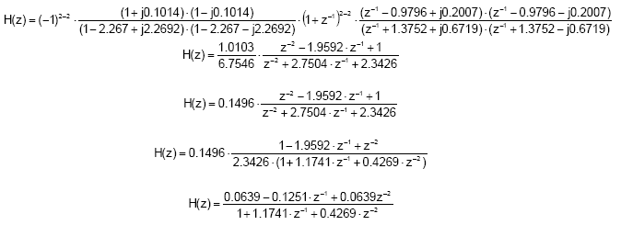

The result is the transfer function of a digital high-pass IIR filter. Realization structure is illustrated in figure below. 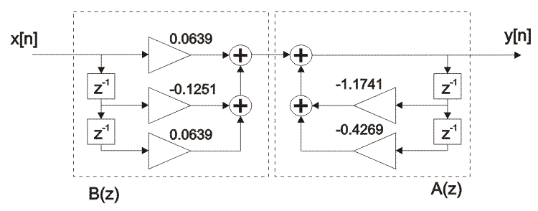

**Figure: 15**

**REFERENCES**

* DSP Computer based approach by S.K. Mitra
* Digital Signal Processing and Digital Filter Design (Draft) Connexions
* Digital Filter Design Synopsis (Somewhere from Internet)
* Design of Digital Filters by J. Fessler
* Steven W. Smith, The Scientist and Engineer’s Guide to Digital Signal

Processing

Some more references from internet whose source cannot be located.